Part A: Review
Question 1
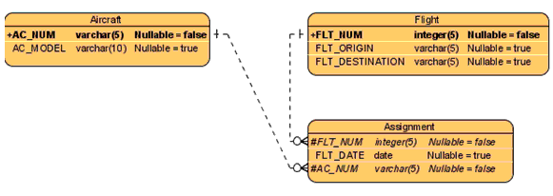
a) Are the relationships in this ERD strong or weak?
b) Which entities are strong and which are weak? Why?
c) What changes are needed to this ERD to show strong vs. weak entities and strong vs. weak relationships?
c) Draw the class diagram equivalent to the following ERD. Include multiplicity. Paste a screenshot of your result here:
d) List business rules behind your association and multiplicity.
e) List the participation for each association

Question 2 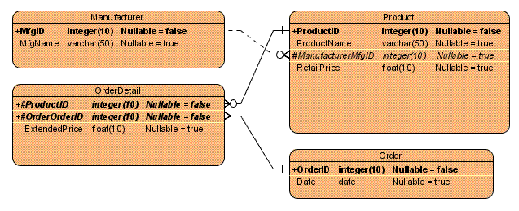
a) Are the relationships in this ERD strong or weak?
b) Which entities are strong and which are weak? Why?
c) What changes are needed to this ERD to show strong vs. weak entities and strong vs. weak relationships?
c) Draw the class diagram equivalent to the following ERD. Include multiplicity. Paste a screenshot of your result here:
d) List business rules behind your association and multiplicity.
e) List the participation for each association

Question 3
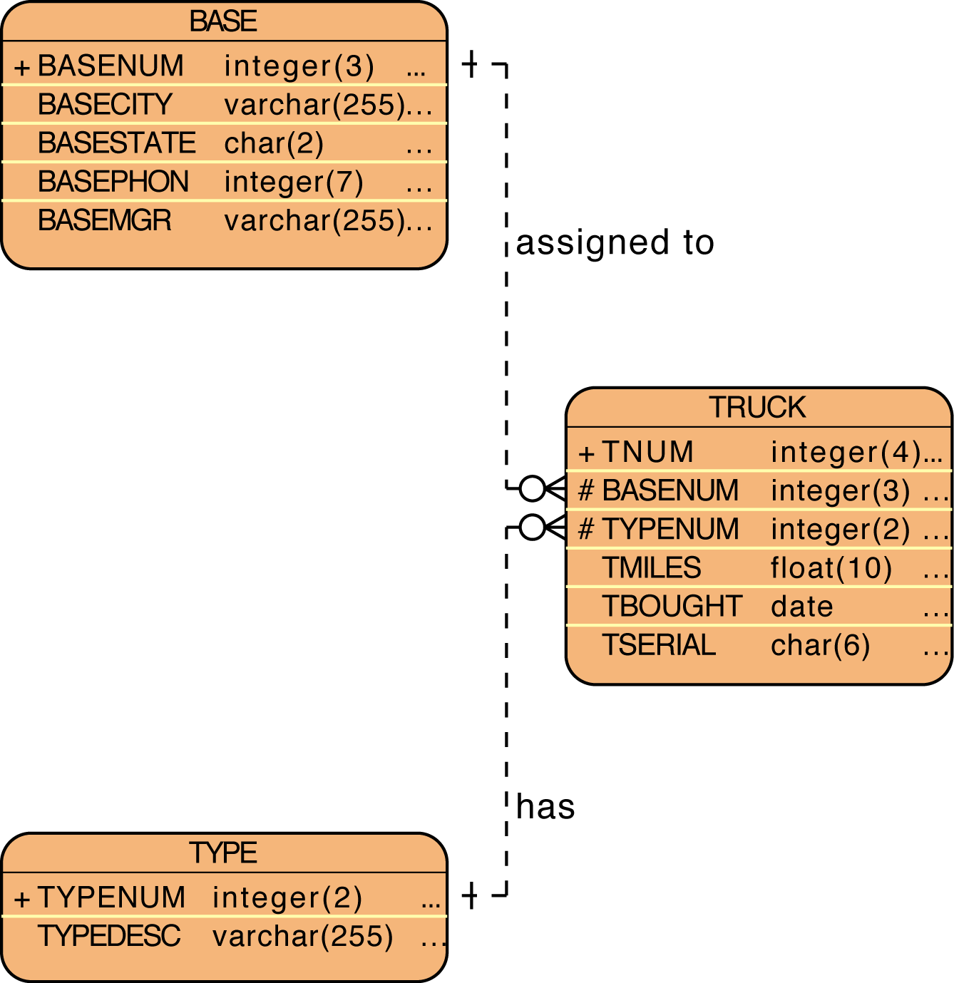

a) Are the relationships in this ERD strong or weak?
b) Which entities are strong and which are weak? Why?
c) What changes are needed to this ERD to show strong vs. weak entities and strong vs. weak relationships?
c) Draw the class diagram equivalent to the following ERD. Include multiplicity. Paste a screenshot of your result here:
d) List business rules behind your association and multiplicity.
e) List the participation for each association

Question 4
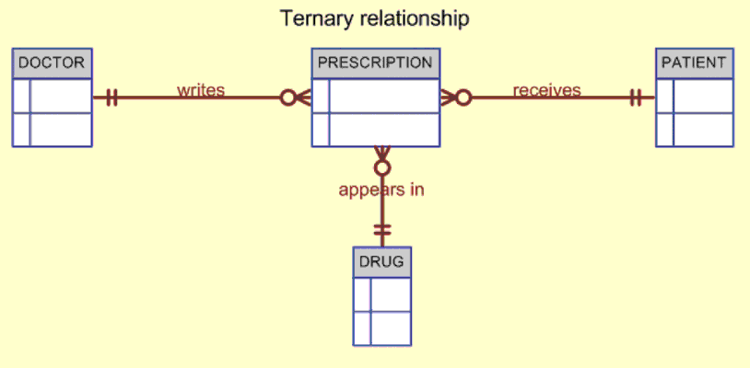

a) Are the relationships in this ERD strong or weak?
b) Which entities are strong and which are weak? Why?
c) What changes are needed to this ERD to show strong vs. weak entities and strong vs. weak relationships?
c) Draw the class diagram equivalent to the following ERD. Include multiplicity. Paste a screenshot of your result here:
d) List business rules behind your association and multiplicity.
e) List the participation for each association

Question 5
Say you work for a company that operates several types of vehicles. Last time you counted, there were 23 different types of license classifications that your employees could have. Several employees have multiple types of vehicle licenses. To store this information in the employee table, the original database developer just kept adding more licence type columns to the employee table. What problem do you see with this practice? What is a proper way to get around this?

Part B: Preview (Please look up on the web)
Question 6
- Describe database normalization in 6 lines or less.
- What is 1st normal form. (6 lines or less)
- What is 2nd normal form. (6 lines or less)
- What is 3rd normal form. (6 lines or less)
Question 7
What is a data warehouse? (4 lines or less)
What is data mining? (4 lines or less)
How is a data warehouse different than an operational database? (6 lines or less)

Question 8
Draw a star schema. Explain the logic behind it and summarize how it helps in data warehousing. (12 lines or less)
Submission Requirements
Due Tuesday January 29 at 10:00PM. Please submit everything in one document marked week3 discussion questions final. All group members must participate. List a summary of questions and persons responsible for each at the beginning of the document. List the name of the person who answered by each question. Split the questions evenly as possible (within reason).

